Flow diagram for cooking oatmeal

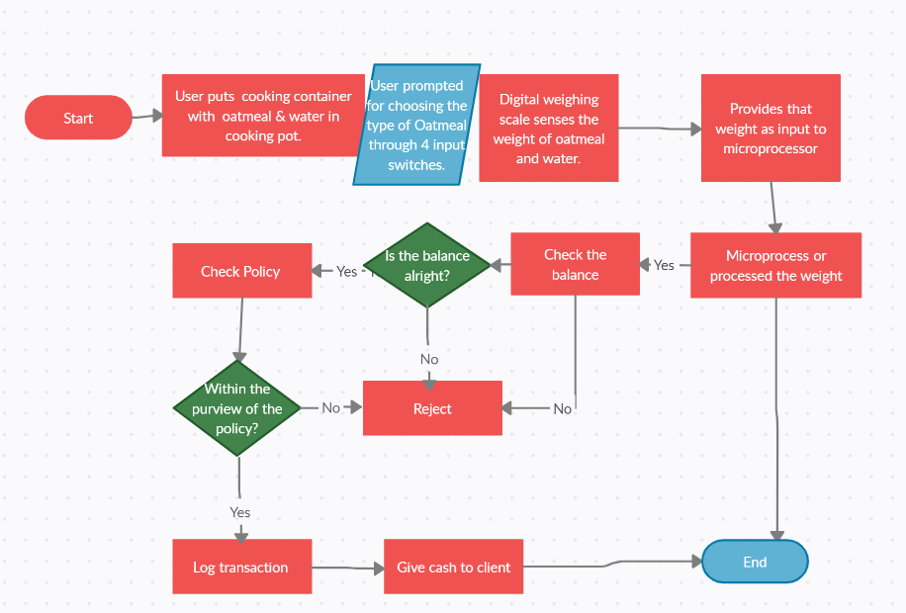

Operations process chart.

Analyze a household process. [ex how to make a sweater]
Include an analysis using
- Flow diagram
- Operations process chart
- Process Flow Chart
- Left Hand/ Right Hand
- PTS++ (MTM method)
Also Add Possible Improvements with Proposed Process

GROUP REPORT (Submission on Assessments folder: Groups of 2)(*1)
You have been hired to observe a current process [HOW TO MAKE OATMEAL IS THE PROCESS]
and develop an improved, more productive operation. Use concepts and terminology from the textbook and slides to produce a report that sells a new solution to a company with hopes of increasing productivity.
Deliverables
1. Analyze a household Process (*2)
2. Record Findings
3. Produce Findings through visuals
4. Make improvements to process
5. Develop Proposed Process
6. Sell Solutions
Your Report Should Include:
• Executive Summary (*3) (10 marks)
• Introduction/description of Process (*4) (5 marks)
• Analysis Tools (15 marks) o Flow diagram
o Operations Process Chart
o Process Flow Chart
o Left Hand/ Right Hand
o PTS ++ (Use MTM method: book and slides)

• Possible Improvements with Proposed Process (10 marks)
• Comments and Conclusion (10 marks)

*1: Pretend you need to convince your boss to get interested in reading your report until the end. Your boss does not have much time but needs to have the “full picture” of the report. ¾ - 1 ½ pages maximum.
*2: Thorough description of the mapped process
** Any similar projects will receive a mark of 0.
** No late submissions

Resources:
https://drive.google.com/drive/folders/1ECgGdOKQhKD2LpXlfYFB0HzuRQ0mcV0a?usp=sharing

